**INDIA GENERAL ELECTIONS RESULT ANALYSIS 2024**

**How many total seats are available in the election?**

select

distinct count(parliament_constituency) as "Total Seats"

from constituencywise_results

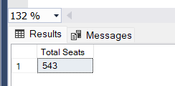

**What are the total number of seats available for elections in each state?**

select

distinct s.State as "State Name",count(*) as "Total Seats"

from constituencywise_results c

inner join statewise_results sr

on c.Parliament_Constituency=sr.Parliament_Constituency

inner join states s on sr.State_ID=s.State_ID

group by s.State;

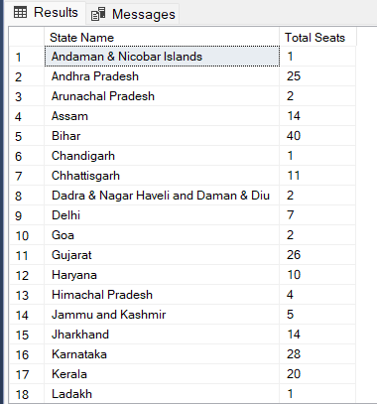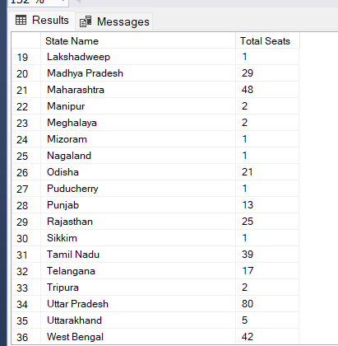

**Total Seats Won by NDA Alliance.**

select

SUM(case

when party IN(

'Bharatiya Janata Party - BJP',

'Telugu Desam - TDP',

'Janata Dal (United) - JD(U)',

'Shiv Sena - SHS',

'AJSU Party - AJSUP',

'Apna Dal (Soneylal) - ADAL',

'Asom Gana Parishad - AGP',

'Hindustani Awam Morcha (Secular) - HAMS',

'Janasena Party - JnP',

'Janata Dal (Secular) - JD(S)',

'Lok Janshakti Party(Ram Vilas) - LJPRV',

'Nationalist Congress Party - NCP',

'Rashtriya Lok Dal - RLD',

'Sikkim Krantikari Morcha - SKM'

) THEN [Won]

ELSE 0

END) as "NDA Total Seats Won"

from

partywise_results;

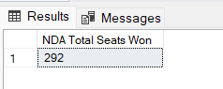

**Seats Won by NDA Alliance Parties.**

select

party as party_name,

won as Seats_won

from

partywise_results

where party IN(

'Bharatiya Janata Party - BJP',

'Telugu Desam - TDP',

'Janata Dal (United) - JD(U)',

'Shiv Sena - SHS',

'AJSU Party - AJSUP',

'Dal (Soneylal) - ADAL',

'Asom Gana Parishad - AGP',

'Hindustani Awam Morcha (Secular) - HAMS',

'Janasena Party - JnP',

'Janata Dal (Secular) - JD(S)',

'Lok Janshakti Party(Ram Vilas) - LJPRV',

'Nationalist Congress Party - NCP',

'Rashtriya Lok Dal - RLD',

'Sikkim Krantikari Morcha - SKM')

order by seats_won DESC;

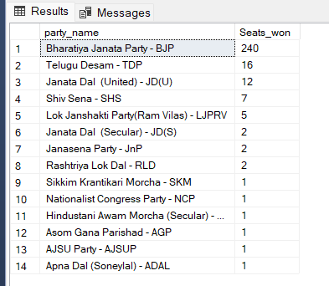

**Total Seats Won by I.N.D.I.A. Alliance.**

SELECT

SUM(CASE

WHEN party IN (

'Indian National Congress - INC',

'Aam Aadmi Party - AAAP',

'All India Trinamool Congress - AITC',

'Bharat Adivasi Party - BHRTADVSIP',

'Communist Party of India (Marxist) - CPI(M)',

'Communist Party of India (Marxist-Leninist) (Liberation) - CPI(ML)(L)',

'Communist Party of India - CPI',

'Dravida Munnetra Kazhagam - DMK',

'Indian Union Muslim League - IUML',

'Nat`Jammu & Kashmir National Conference - JKN',

'Jharkhand Mukti Morcha - JMM',

'Jammu & Kashmir National Conference - JKN',

'Kerala Congress - KEC',

'Marumalarchi Dravida Munnetra Kazhagam - MDMK',

'Nationalist Congress Party Sharadchandra Pawar - NCPSP',

'Rashtriya Janata Dal - RJD',

'Rashtriya Loktantrik Party - RLTP',

'Revolutionary Socialist Party - RSP',

'Samajwadi Party - SP',

'Shiv Sena (Uddhav Balasaheb Thackrey) - SHSUBT',

'Viduthalai Chiruthaigal Katchi - VCK'

) THEN [Won]

ELSE 0

END) AS INDIA_Total_Seats_Won

FROM

partywise_results;

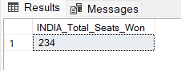

**Seats Won by I.N.D.I.A. Alliance Parties.**

SELECT

party as party_name,

won as Seats_won

from partywise_results

WHERE party IN (

'Indian National Congress - INC',

'Aam Aadmi Party - AAAP',

'All India Trinamool Congress - AITC',

'Bharat Adivasi Party - BHRTADVSIP',

'Communist Party of India (Marxist) - CPI(M)',

'Communist Party of India (Marxist-Leninist) (Liberation) - CPI(ML)(L)',

'Communist Party of India - CPI',

'Dravida Munnetra Kazhagam - DMK',

'Indian Union Muslim League - IUML',

'Nat`Jammu & Kashmir National Conference - JKN',

'Jharkhand Mukti Morcha - JMM',

'Jammu & Kashmir National Conference - JKN',

'Kerala Congress - KEC',

'Marumalarchi Dravida Munnetra Kazhagam - MDMK',

'Nationalist Congress Party Sharadchandra Pawar - NCPSP',

'Rashtriya Janata Dal - RJD',

'Rashtriya Loktantrik Party - RLTP',

'Revolutionary Socialist Party - RSP',

'Samajwadi Party - SP',

'Shiv Sena (Uddhav Balasaheb Thackrey) - SHSUBT',

'Viduthalai Chiruthaigal Katchi - VCK')

ORDER BY Seats_won DESC;

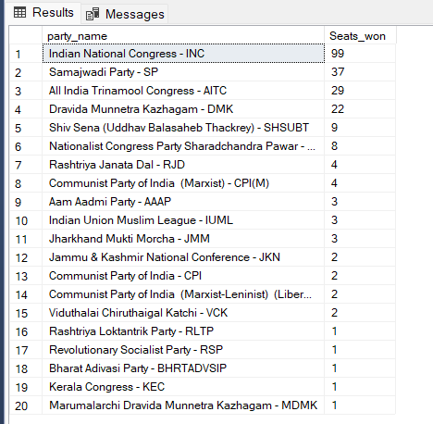

**Add new column field in table partywise_results to get the party Alliance as NDA,I.N.D.I.A. and Other.**

ALTER TABLE partywise_results

add "Party Alliance" varchar(50)

I.N.D.I.A.

UPDATE partywise_results

SET "Party Alliance" = 'I.N.D.I.A'

WHERE party IN (

'Indian National Congress - INC',

'Aam Aadmi Party - AAAP',

'All India Trinamool Congress - AITC',

'Bharat Adivasi Party - BHRTADVSIP',

'Communist Party of India (Marxist) - CPI(M)',

'Communist Party of India (Marxist-Leninist) (Liberation) - CPI(ML)(L)',

'Communist Party of India - CPI',

'Dravida Munnetra Kazhagam - DMK',

'Indian Union Muslim League - IUML',

'Jammu & Kashmir National Conference - JKN',

'Jharkhand Mukti Morcha - JMM',

'Kerala Congress - KEC',

'Marumalarchi Dravida Munnetra Kazhagam - MDMK',

'Nationalist Congress Party Sharadchandra Pawar - NCPSP',

'Rashtriya Janata Dal - RJD',

'Rashtriya Loktantrik Party - RLTP',

'Revolutionary Socialist Party - RSP',

'Samajwadi Party - SP',

'Shiv Sena (Uddhav Balasaheb Thackrey) - SHSUBT',

'Viduthalai Chiruthaigal Katchi - VCK'

);

NDA

UPDATE partywise_results

SET "Party Alliance" = 'NDA'

WHERE party IN (

'Bharatiya Janata Party - BJP',

'Telugu Desam - TDP',

'Janata Dal (United) - JD(U)',

'Shiv Sena - SHS',

'AJSU Party - AJSUP',

'Apna Dal (Soneylal) - ADAL',

'Asom Gana Parishad - AGP',

'Hindustani Awam Morcha (Secular) - HAMS',

'Janasena Party - JnP',

'Janata Dal (Secular) - JD(S)',

'Lok Janshakti Party(Ram Vilas) - LJPRV',

'Nationalist Congress Party - NCP',

'Rashtriya Lok Dal - RLD',

'Sikkim Krantikari Morcha - SKM'

);

Other

Update partywise_results

SET "Party Alliance"='Other'

where "Party Alliance" is NULL;

select "Party Alliance",

sum(Won)

from partywise_results

group by "Party Alliance";

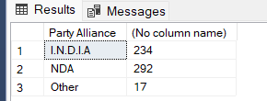

**Winning candidate's name, theie party name, total votes, and the margin of victory for a specific state and constituency.**

SELECT

cr.winning_candidate,

pr.party,

cr.total_votes,

cr.margin,

s.state,

cr.constituency_name

from constituencywise_results cr

inner join partywise_results pr on cr.Party_ID=pr.Party_ID

inner join statewise_results sr on cr.parliament_constituency=sr.Parliament_Constituency

inner join states s on sr.State_ID=s.State_ID

where cr.constituency_name like 'NASHIK';

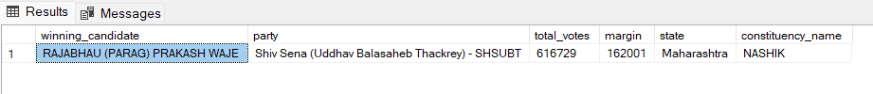

**What is the distribution of EVM votes vs postal votes for candidates in a specific constituency.**

SELECT

cd.EVM_Votes,

cd.Postal_Votes,

cd.Total_Votes,

cd.candidate,

cr.constituency_name

from constituencywise_results cr join constituencywise_details cd

on cr.Constituency_ID = cd.Constituency_ID

where cr.Constituency_Name='AKOLA';

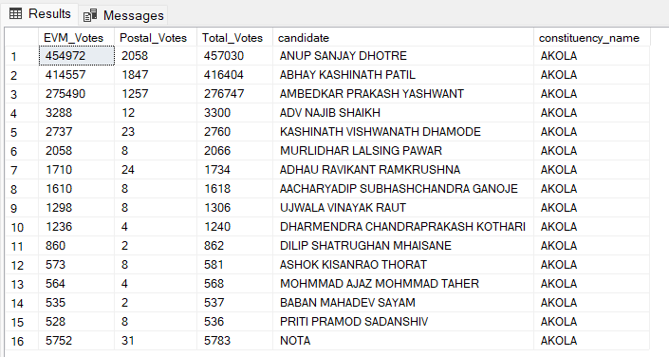

**Which parties won the most seates in a State, and how many seats each party win.**

SELECT

p.Party,

COUNT(cr.Constituency_ID) AS Seats_Won

FROM constituencywise_results cr

JOIN partywise_results p ON cr.Party_ID = p.Party_ID

JOIN statewise_results sr ON cr.Parliament_Constituency = sr.Parliament_Constituency

JOIN states s ON sr.State_ID = s.State_ID

WHERE s.state = 'Maharashtra'

GROUP BY p.Party

ORDER BY Seats_Won DESC;

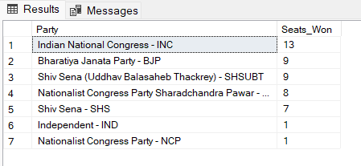

**What is the total number of seats won by each party alliance (NDA, I.N.D.I.A. and Other) each state for the India Elections 2024.**

SELECT

s.state,

sum(case when p."Party Alliance" = 'NDA' then 1 else 0 end) as NDA_Seats_Won,

sum(case when p."Party Alliance" = 'I.N.D.I.A' then 1 else 0 end) as INDIA_Seats_Won,

sum(case when p."Party Alliance" = 'Other' then 1 else 0 end) as Other_Seats_Won

FROM constituencywise_results cr

JOIN partywise_results p ON cr.Party_ID = p.Party_ID

JOIN statewise_results sr ON cr.Parliament_Constituency = sr.Parliament_Constituency

JOIN states s ON sr.State_ID = s.State_ID

WHERE s.state = 'Maharashtra'

Group by s.state

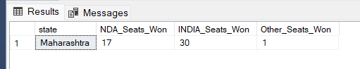

**Which candidate received the highest number of EVM votes in each constituency(TOP 10)?**

SELECT TOP 10

cr.Constituency_Name,

cd.Constituency_ID,

cd.Candidate,

cd.EVM_Votes

from constituencywise_results cr

inner join constituencywise_details cd on cr.Constituency_ID=cd.Constituency_ID

where cd.EVM_Votes = (

select MAX(cd1.EVM_Votes)

from constituencywise_details cd1

where cd1.Constituency_ID=cd.Constituency_ID

)

ORDER BY

cd.EVM_Votes DESC;

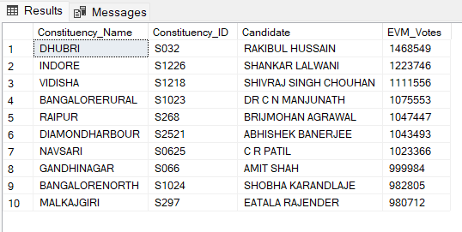

**Which candidate won and which candidate was the runner-up in each constituency of state for the 2024 elections?**

WITH RankedCandidates AS (

SELECT

cd.Constituency_ID,

cd.Candidate,

cd.Party,

cd.EVM_Votes,

cd.Postal_Votes,

cd.EVM_Votes + cd.Postal_Votes AS Total_Votes,

ROW_NUMBER() OVER (PARTITION BY cd.Constituency_ID

ORDER BY cd.EVM_Votes + cd.Postal_Votes DESC) AS VoteRank

FROM constituencywise_details cd

JOIN constituencywise_results cr ON cd.Constituency_ID = cr.Constituency_ID

JOIN statewise_results sr

ON cr.Parliament_Constituency = sr.Parliament_Constituency

JOIN states s ON sr.State_ID = s.State_ID

WHERE s.State = 'Maharashtra')

SELECT

cr.Constituency_Name,

MAX(CASE WHEN rc.VoteRank = 1 THEN rc.Candidate END) AS Winning_Candidate,

MAX(CASE WHEN rc.VoteRank = 2 THEN rc.Candidate END) AS Runnerup_Candidate

FROM RankedCandidates rc

JOIN constituencywise_results cr ON rc.Constituency_ID = cr.Constituency_ID

GROUP BY cr.Constituency_Name

ORDER BY cr.Constituency_Name;

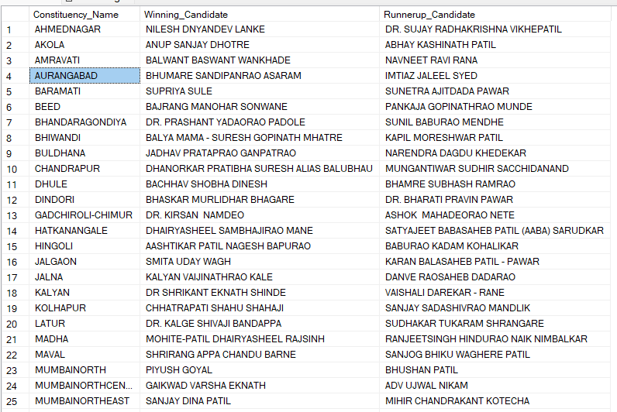

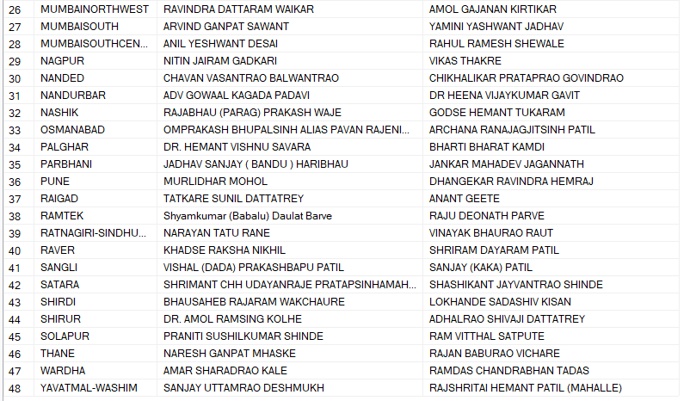 **For the state of Maharashtra, what are the total number of seats, total number of candidates, total number of parties, total votes (including EVM and postal), and the breakdown of EVM and postal votes?**

SELECT

COUNT(DISTINCT cr.Constituency_ID) AS Total_Seats,

COUNT(DISTINCT cd.Candidate) AS Total_Candidates,

COUNT(DISTINCT p.Party) AS Total_Parties,

SUM(cd.EVM_Votes + cd.Postal_Votes) AS Total_Votes,

SUM(cd.EVM_Votes) AS Total_EVM_Votes,

SUM(cd.Postal_Votes) AS Total_Postal_Votes

FROM constituencywise_results cr

JOIN constituencywise_details cd ON cr.Constituency_ID = cd.Constituency_ID

JOIN statewise_results sr ON cr.Parliament_Constituency = sr.Parliament_Constituency

JOIN states s ON sr.State_ID = s.State_ID

JOIN partywise_results p ON cr.Party_ID = p.Party_ID

WHERE s.State = 'Maharashtra';

